**Project Design Phase-II**

**Data Flow Diagram &User Stories**

|  |  |
| --- | --- |
| Date | 12 October 2022  . |
| Team ID | PNT2022TMID20238 |
| Project Name | Plasma Donor Application |
| Maximum Marks | 4 Marks |

**Data Flow Diagram:**

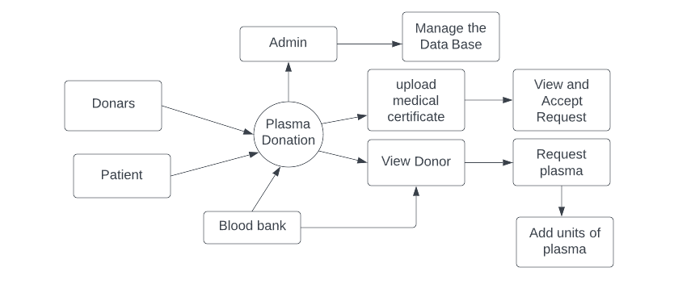

**User Stories:**

| **User Type** | **Functional Requirement (Epic)** | **User Story Number** | **User Story / Task** | **Acceptance criteria** | **Priority** | **Release** |
| --- | --- | --- | --- | --- | --- | --- |
| Customer (Mobile user) | Registration | USN-1 | As a user, I can register for the application by entering my email, password, and confirming my password. | I can access my account / dashboard | High | Sprint-1 |
|  | Confirmation | USN-2 | As a user, I will receive confirmation email once I have registered for the application | I can receive confirmation email & click confirm | High | Sprint-1 |
|  | Access application | USN-3 | As a user, I can register for the application through application | I can register & access the application | Low | Sprint-2 |
|  | Registration Gmail | USN-4 | As a user, I can register for the application through Gmail | I can receive successful  registration Gmail | Medium | Sprint-1 |
|  | Login | USN-5 | As a user, I can log into the application by entering email & password | I can enter into application successfully | High | Sprint-1 |
| Customer (Web user) | Access Website | USN-6 | Capable to access web application through an browser | I can access web-application | Medium | Sprint-1 |
|  | Search for donor | USN-7 | Search result can be viewed in a list | I can view list represents a specific donor with donor details | High | Sprint-1 |
| Customer Care Executive | Software Operator | USN-8 | Should be able to register through application. Donor must provide username, gender, blood group, location, contact. | The user’s response surprised us positively | High | Sprint-1 |
|  | View request | USN-9 | The customer care executive should be able to view received request and then respond to them | We can receive the request response immediately | High | Sprint-1 |
| Administrator | Maintenance | USN-10 | Admin can access, view, modify, update all details of the plasma donor application | Admin is the authorized person of the overall application. | High | Sprint-1 |